**CHAPTER 2**

BE STYLED WITH CSS

**OBJECTIVES FOR TODAY **

✓ What is a **CSS rule** ?

✓ Create your CSS rules to add color, fonts, borders to your ugly HTML!

REVIEW

Nested elements graph

**<html>**

**<head>** 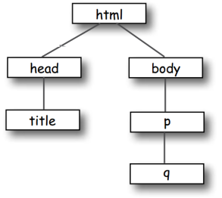

**<title>**Musings**</title>**

**</head>**

**<body>**

**<p>**

To quote Buckaroo,

**<q>**The only reason

for time is so

that everything

doesn’t happen

at once**.</q>**

**</p>**

**</body>**

**</html>**

PRACTICE

10 MIN INDIV

**Draw nested elements graph**

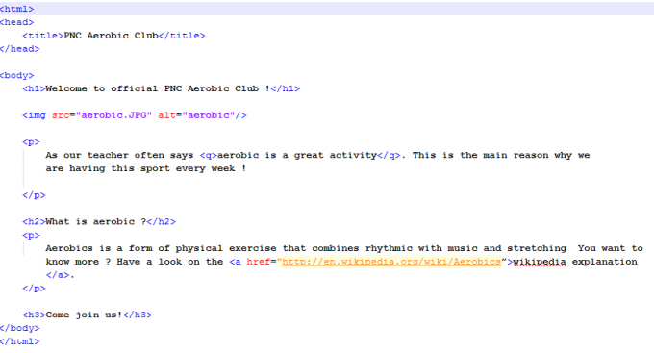

REVIEW

5 MIN CLASS

Draw nested elements graph

html

head body

title h1 img p q

h1 p a

h3

DEMO

5 MIN CLASS

CSS makes the life more beautiful 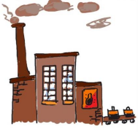

CSS

HTML

MAGIC

FACTORY

HTML + CSS

The page with a CSS style

EXPLAIN

Let’s decorate my house A rule consists of a **location** and a **property**

bathroom {

toilet-color : pink;

}

**bathroom** {

toilet-color : pink; }

**kitchen** {

fridge-color : green; }

EXPLAIN

Write you first rule in CSS

There is a

**p {**

colon here There is a semi colon at the end

**color : red; }**

Select the **element** you want to style

Specify the **property** you want to style

Set the **color** of paragraph in red

EXPLAIN

3 ways to set your CSS style

**1. INLINE** :

I white CSS inside the tag inside the HTML file

<h1 style="color:blue; font-size:14px;">This is my title</h1>

**2. BLOCK** :

use the tag **<style>** inside my HTML file, inside <head>

<head>

<style> h1 {color:blue; font-size:14px;} </style> </head>

**3. EXTERNAL** :

I use an other file : style.css

PRACTICE



40 MIN 2

1. Group of 2

**p {**

**color : red; }**

Background color = bisque

2. Check CSS documentation on the WEB: 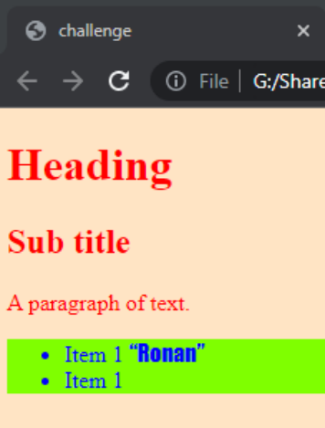

h1

http://www.w3schools.com/cssref/

3. Write your code in **2 separate files**

h2

(external method)

4. Explain your results to others

<head> </head>

**HELP** 

<link rel="stylesheet" href="stylesheet.css">

Quote +

Font family = fantasy

Background color = chartreuse

PRACTICE

10 MIN INDIV

Let’s learn the internal methods

✓ Get the folder aerobic and edit **aerobic.html** and **fans.html**

✓ Add a style element to :

• Display paragraphs in BLUE

• Display H1 in RED

• Display H2 in GREEN

EXPLORE



5 MIN 2

How can we know the list of all CSS properties ? 

http://www.w3schools.com/cssref/

**NOW YOU KNOW **

✓ What is a **CSS rule** ?

✓ Create your CSS rules to add color, fonts, borders to your ugly HTML!

HOMEWORK 



INDIV

After class what to do ?

1. Read the handout I give you now.

2. Do the required homework

3. Send your homework to Google Classroom